**assignment:26**

**Use the Store_Data data and do the following**

**- Conduct a Market Basket Analysis**

**- Perform the required Join Operations to do this.**

**- The market basket analysis should be in terms of Product Sub category and Order ID**

Under Connect section, click on "Microsoft Excel" and browse through the location where "Store_Data" excel file exists to connect.

After connecting to "Store_Data" excel data,

As we can see there are three tables as shown below:



First, we need to create another "Orders" table and establish connection with the existing "Orders" table.

In the Data Source page:

step 1) Drag and drop "Orders" table to Model View section.

step 2) Double click on "Orders" table in the Model View section.

step 3) Now, Once again drag and drop " Orders" table to model view section.

Then tableau prompts you to establish a relationship with Orders table for this new "Orders 1" table.

Here, we need to establish connection with the help of matching fields:

step 4) Select "Order ID" from first table and also select "Order ID" from second table as shown below

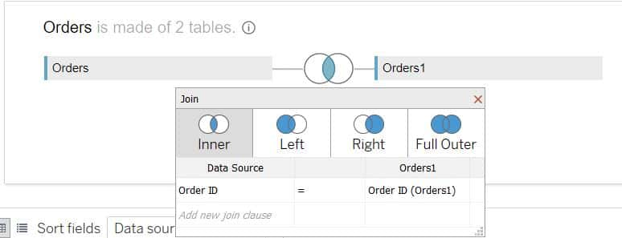

Lets create one more relationship i.e "Product Sub-Category":

step 5) Select "Product Sub-Category" from first table and select "not equal" i.e <> operator then select "Product Sub-Category" from second table as shown below

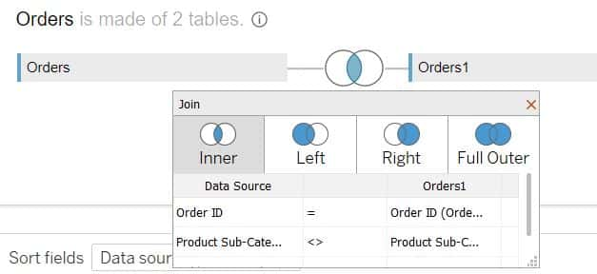

Hence, the relationship is established between the two tables.

Lets now make some visualization with Order ID and Product Sub-Category:

Go to sheet 1 and rename it as "Market Basket Analysis".

step 6) Drag and drop "Product Sub-Category" dimension of "Orders" table on to Rows shelf.

step 7) Drag and drop "Product Sub-Category" dimension of "Orders1" table on to Columns shelf.

Now, we can see the custom visual on the screen which is useful for market basket analysis.

We can also change view type to "Entire View" for better visual representation.

In order to make market basket analysis on Order ID, we need to create a distinct count for Order ID in terms of Text and Color.

So, lets do this:

step 8) Drag and drop "Order ID" measure of "Orders" table on to Text under Marks card.

Then right click on "Order ID" pill under Marks card and change Measure type to "Count(Distinct)".

step 9) Drag and drop "Order ID" measure of "Orders" table on to Color under Marks card.

In the pop up window, click on "add all members".

Then right click on "Order ID" color pill under Marks card and change Measure type to "Count(Distinct)".

We can also change the data of Order ID into a shape:

step 10) Change Mark type to "Square".

we can see the visual as shown below:

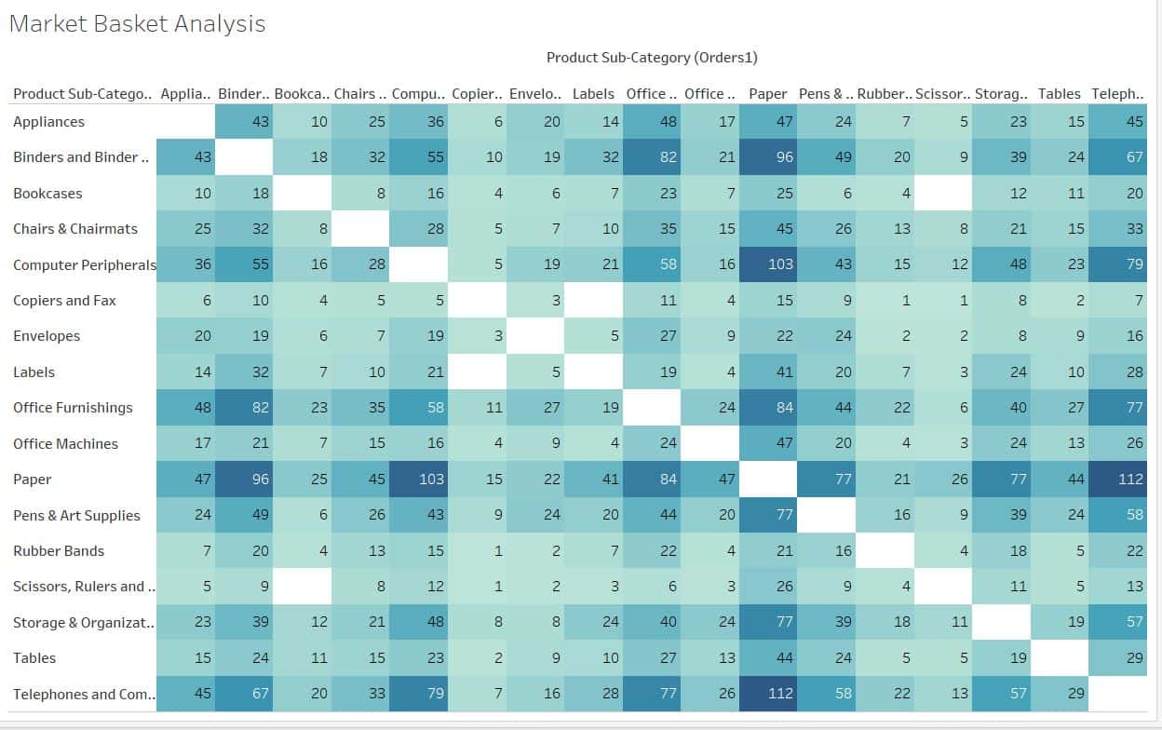

We can see that both the sections of this chart have same numbers.

So, lets remove the left hand section of the chart:

step 11) Go back to Data Source page.

Click on the joint part of tables in mode view section and set "<" relation between "Product Sub-Category" relationship as shown below:

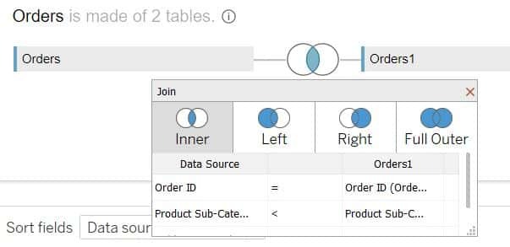

Now, we can see the left hand section has been removed in the visual as shown below:

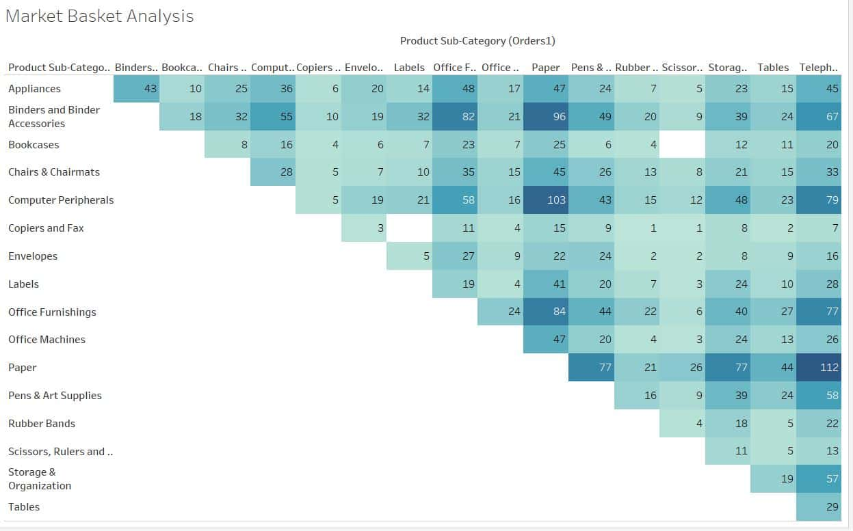

step 12) press ctrl+w to swap rows and columns.

Now, we can see Market Basket Analysis Visual in terms of Product Sub-Category and Order ID as shown below:

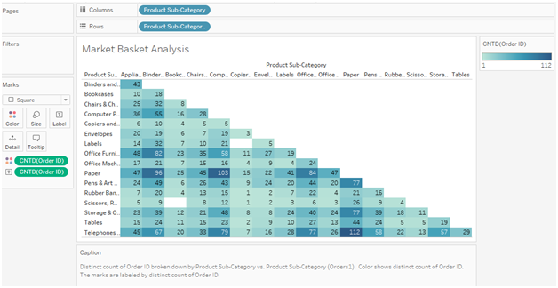

**Insights:**

• "Telephones and Communication" sub category and "Paper" sub category have distinct count of orders as 112 which is highest.

• "Rubber Bands, Scissors, Rulers and Trimmers" against "Copiers and Fax" have distinct count of orders as 1 which is lowest.